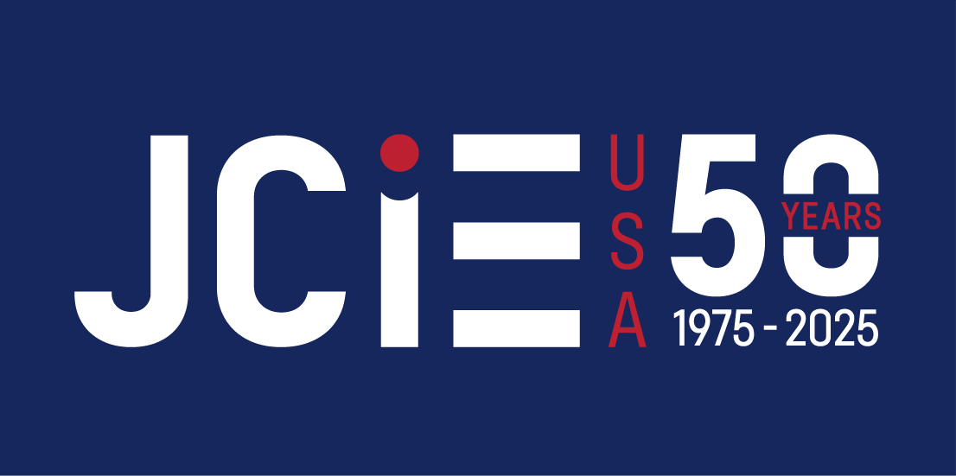 | Japan Center for International Exchange (JCIE)  US-Japan Political Exchange Program

US Congressional Staff Exchange

2025 Delegation to Japan

Candidate Profile

Please return the completed form to: kbayes@jcie.org (cc: info@jcie.org)

Name:
Position/title:
Office address:
TEL: | Email:
1. Employment History in Congress (position, office/committee, dates):
2. Other Professional Experience:
3. International experience (if applicable) *Please note any experience you’ve had with Japan:

4. What do you hope to get out of participating in this program? (200-300 words)
5. How will a deeper understanding of Japan and U.S.-Japan relations as well as ties to Japanese policymakers and experts contribute to your work and, more broadly, to that of your office? (200-300 words)
6. This program is geared towards staffers with commitment to a career in public service. What are your career goals, and how might this program support them? (200-300 words)

7. Are there specific policy areas or questions (e.g. security, trade, development assistance, etc.) that you would be interested in exploring, organizations you would like to engage with, or places you would like to visit if you are accepted to this program?

8. How will your participation contribute to adding unique and new perspectives? Please feel free to mention elements of your own background or personal experience in answering (200-300 words)

Japan Center for International Exchange USA (JCIE USA)
475 Riverside Drive, Suite 731
New York, NY 10115
TEL: (212) 679-4130
URL: www.jcie.org

